**Kedir Nasir Omer Date: Nov. 28/2022**

**UC SanDiego- Big Data Specialization**

**3.2. Training Data Set Creation**

* **Recommending Actions from Clustering Analysis**

The first five lines of the training data set used for this analysis are displayed below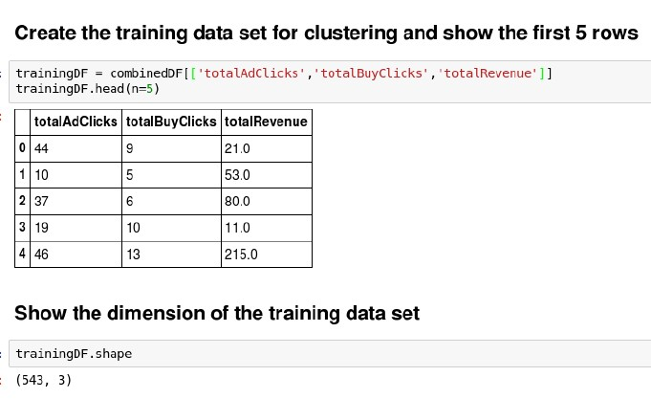

* Dimensions (rows x columns) of the training data set: 3 columns x 543 rows
* 3 clusters were produced